**Controlling**

CO 1: Review Cost Center Standard Hierarchy

Submit answers to the following questions (5 points)

What is N5000?

N5000 is a Group Name code which refers to the Group Name: Information Technology which is a second level element.

What is NAMK1000?

NAMK1000 is the cost centre: NA Marketing Costs, under the Group Name: Marketing. NAMK1000 is the 3rd level element in the hierarchy.

CO 2: Display Cost Elements

Submit the screen shot of Cost element tab screen (2.5 points)

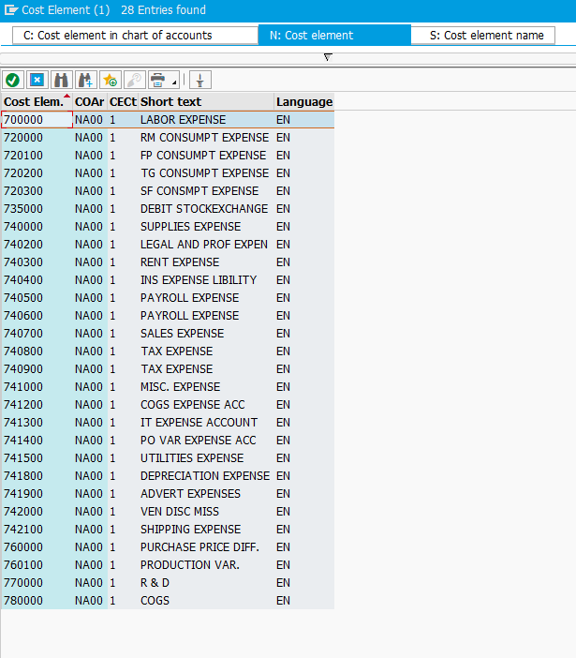

What is this cost element’s validity period (2.5 points)?

01/01/2009 – 12/31/9999

What is this cost element’s CElem category (2.5 points)?

The cost element’s CElem category for this is 43.

Can you explain the difference between cost element Labor (700000) and Labor (800000) (2.5 points)?

Under the primary cost/cost-reducing revenue category, Labor(700000) is a primary cost element. Cost-reducing revenue category collects revenues that are to be handled in CO like overhead costs. This reduces the price of an activity type or the cost to be assessed.

Labor(800000) is a secondary cost element in the internal activity allocation category. This is used to allocate cost during the internal activity allocation and for allocating process cost.

CO 3: Display Cost Element Groups

Submit a screen shot of the above screen (2.5 points).

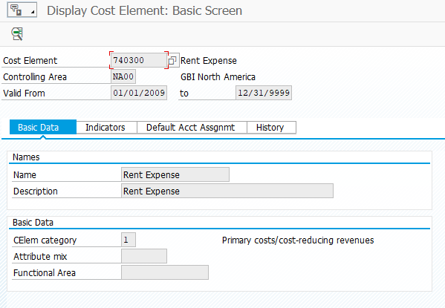

What is the unique number for cost element group “EU Secondary Cost Element Total” (2.5 points)?

8999999

